EXERCISE 5:
Verify if master is in clean state
- git checkout master
- git status
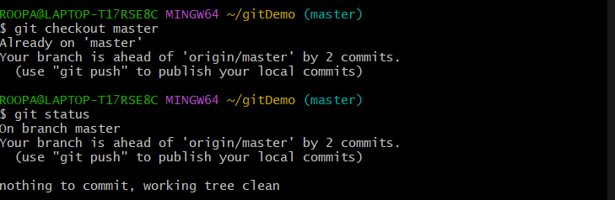
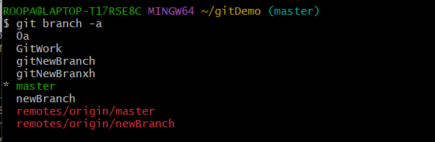
List all available branches
- git branch -a
Pull latest changes from remote
- git pull origin master
Push your local commits to remote
- git push origin master
